Submitted By: Shanza Batool (23-NTU-CS-1209)
Submitted To: Sir Nasir Mehmood
Operating Systems – COC 3071
SE 5th A – Fall 2025
After-mid Homework -1

Part 1: Semaphore theory
- A counting semaphore is initialized to 7. If 10 wait() and 4 signal() operations are performed, find the final value of the semaphore.

- Initial value:
S = 7
- Each wait() decreases by 1:
10 wait → 7 - 10 = -3
- Each signal() increases by 1:
4 signal → -3 + 4 = 1
- Final value:
1
- A semaphore starts with value 3. If 5 wait() and 6 signal() operations occur, calculate the resulting semaphore value.
- Initial:
S = 3
- 5 wait →
3 - 5 = -2
- 6 signal → -
2 + 6 = 4
- Final value:
4
- A semaphore is initialized to 0. If 8 signal() followed by 3 wait() operations are executed, find the final value.
- Initial:
S = 0
- 8 signal →
0 + 8 = 8
- 3 wait →
8 - 3 = 5
- Final value:
5
- A semaphore is initialized to 2. If 5 wait() operations are executed:
- How many processes enter the critical section?
- How many processes are blocked?

- Initial: S = 2
- Max 2 processes can enter the critical section (value > 0)
- Remaining 3 wait operations are blocked
a) Processes entered: 2
b) Processes blocked: 3
5. A semaphore starts at 1. If 3 wait() and 1 signal() operations are performed:
- How many processes remain blocked?
- What is the final semaphore value?
- Initial: S = 1
- 3 wait → 1 - 3 = -2 (so 2 processes blocked)
- 1 signal → -2 + 1 = -1
a) Processes blocked: 1 (still waiting)
b) Final value: -1
“Negative semaphore value = number of blocked processes”

6.
semaphore S = 3;
wait(S); wait(S); signal(S); wait(S); wait(S);

- How many processes enter the critical section?
- What is the final value of S?

Operation | S value | Entry in Critical Section
Initial (S) | 3
Wait (S) | 2 | Enters Critical Section
Wait (S) | 1 | Enters Critical Section
Signal (S) | 2 | Releases Critical Section
Wait (S) | 1 | Enters Critical Section
Wait (S) | 0 | Enters Critical Section
a) Processes entered: 4
b) Final value: 0
7.
semaphore S = 1;
wait(S); wait(S); signal(S); signal(S);

- How many processes are blocked?
- What is the final value of S?

Operation | S value | Entry in Critical Section
Initial (S) | 1
Wait (S) | 0 | Enters Critical Section
Wait (S) | -1 | Blocked one process
Signal (S) | 0 | Unblock one process
Signal (S) | 1 | Releases Critical Section
  - Processes blocked: 0 (all processes are unblocked after signal)
  - Final value: 1

- A binary semaphore is initialized to 1. Five wait() operations are executed without any signal(). How many processes enter the critical section and how many are blocked?
- Initial: S = 1
- First wait → 0 → enters CS
- Next 4 wait → -1, -2, -3, -4 → blocked
Processes entered CS: 1
Processes blocked: 4
- A counting semaphore is initialized to 4. If 6 processes execute wait() simultaneously, how many proceed and how many are blocked?

- Initial: S = 4
- First 4 processes → S = 0 → enter CS
- Last 2 processes → blocked
Processes proceed: 4
Processes blocked: 2
- A semaphore S is initialized to 2. wait(S); wait(S); wait(S); signal(S); signal(S);
wait(S);

- Track the semaphore value after each operation.
- How many processes were blocked at any time?

Operation | S value | Critical Section
Initial | 2
Wait(S) | 1 | Enters Critical Section
Wait(S) | 0 | Enters Critical Section
Wait(S) | -1 | Block one process
Signal(S) | 0 | Unblock one process
Signal(S) | 1 | Release Critical Section
Wait(S) | 0 | Enters Critical Section
a) Semaphore after each operation: 2 → 1 → 0 → -1 → 0 → 1 → 0
b) Processes blocked at any time: 1
11. A semaphore is initialized to 0. Three processes execute wait() before any signal(). Later, 5 signal() operations are executed. a) How many processes wake up?
b) What is the final semaphore value?

Step 1: Execute 3 wait() operations
Initial value = 0
Step 2: Execute 5 signal() operations
Each signal() first wakes a blocked process if any exist.
a) Processes wake up: 3
b) Final semaphore value: 2
Part 2: Semaphore Coding
Consider the Producer–Consumer problem using semaphores as implemented in Lab-10 (Lab-plan attached). Rewrite the program in your own coding style, compile and execute it successfully, and explain the working of the code in your own words.
Submission Requirements:
- Your rewritten source code
- A brief description of how the code works
- Screenshots of the program output showing successful execution
Code:
#include <stdio.h>
#include <pthread.h>
#include <semaphore.h>
#include <unistd.h>
#define BUFFER_CAPACITY 5
#define ITEMS_TO_PRODUCE 3

int sharedBuffer[BUFFER_CAPACITY];
int writeIndex = 0;
int readIndex = 0;

sem_t spacesAvailable;
sem_t itemsAvailable;
pthread_mutex_t bufferMutex;

// Producer function
void* produceItems(void* arg) {
int producerId = (int)arg;

for (int i = 0; i < ITEMS_TO_PRODUCE; i++) {
sem_wait(&spacesAvailable); // Wait for empty slot
pthread_mutex_lock(&bufferMutex); // Lock buffer

sharedBuffer[writeIndex] = producerId * 10 + i;
printf("Producer-%d produced %d\n", producerId, sharedBuffer[writeIndex]);
writeIndex = (writeIndex + 1) % BUFFER_CAPACITY;

pthread_mutex_unlock(&bufferMutex); // Unlock buffer
sem_post(&itemsAvailable); // Signal item is available

sleep(1); // Simulate production
}

return NULL;
}
// Consumer function
void* consumeItems(void* arg) {
int consumerId = (int)arg;
for (int i = 0; i < ITEMS_TO_PRODUCE; i++) {
sem_wait(&itemsAvailable); // Wait for item
pthread_mutex_lock(&bufferMutex); // Lock buffer
printf("Consumer-%d consumed %d\n", consumerId, sharedBuffer[readIndex]);
readIndex = (readIndex + 1) % BUFFER_CAPACITY;

pthread_mutex_unlock(&bufferMutex); // Unlock buffer
sem_post(&spacesAvailable); // Signal space is available

sleep(2); // Simulate consumption
}
return NULL;
}
int main() {
pthread_t producers[2], consumers[2];
int ids[2] = {101, 102};
// Initialize semaphores and mutex
sem_init(&spacesAvailable, 0, BUFFER_CAPACITY);
sem_init(&itemsAvailable, 0, 0);
pthread_mutex_init(&bufferMutex, NULL);
// Start producer and consumer threads
for (int i = 0; i < 2; i++) {
pthread_create(&producers[i], NULL, produceItems, &ids[i]);
pthread_create(&consumers[i], NULL, consumeItems, &ids[i]);
}
// Wait for all threads to finish
for (int i = 0; i < 2; i++) {
pthread_join(producers[i], NULL);
pthread_join(consumers[i], NULL);
}
// Clean up
sem_destroy(&spacesAvailable);
sem_destroy(&itemsAvailable);
pthread_mutex_destroy(&bufferMutex);
return 0;
}

Output:
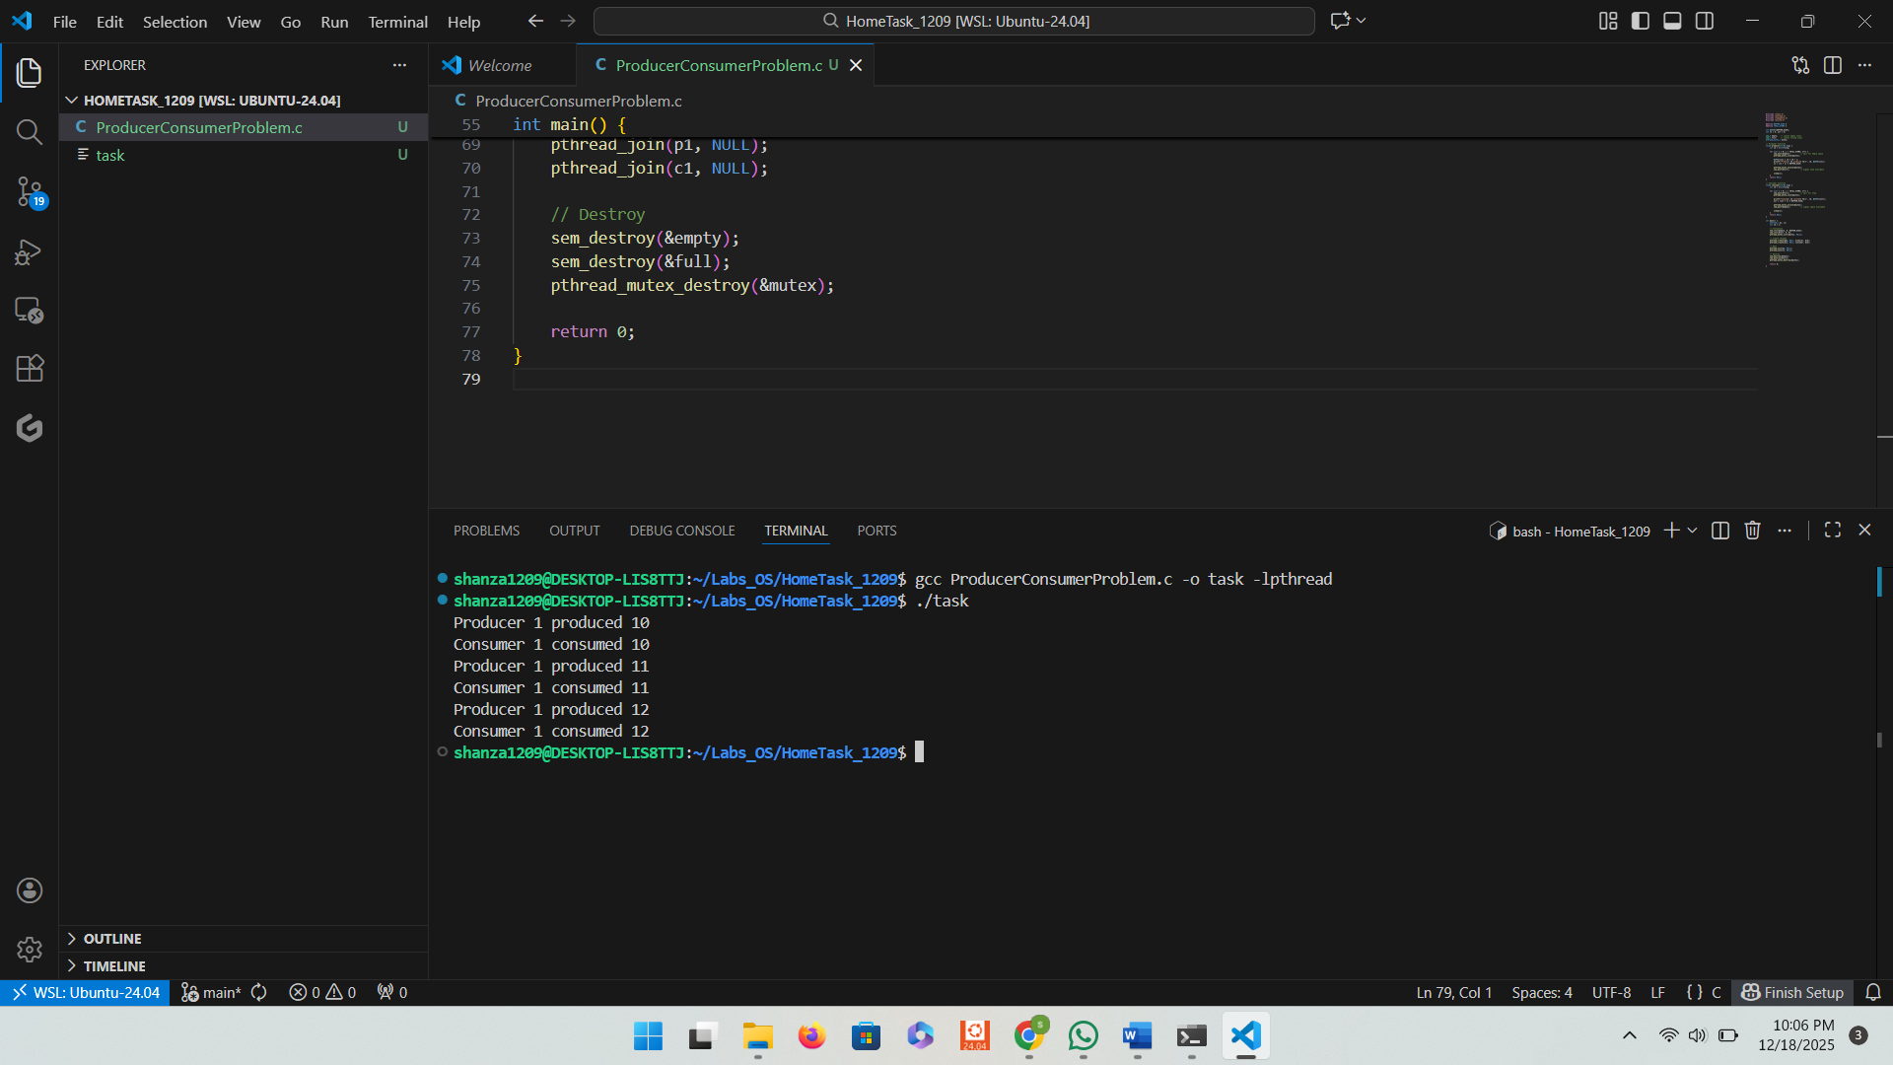
Description Summary:
- Uses a shared buffer of fixed size for storing items.
- Producer thread: produces items and adds them to the buffer.
- Consumer thread: consumes items from the buffer.
- Semaphores:
- emptySlots → counts empty spaces; producer waits if full.
- filledSlots → counts filled slots; consumer waits if empty.
- Mutex ensures mutual exclusion when accessing the buffer.
- Producer workflow:
- Waits for empty slot (sem_wait(emptySlots))
- Locks buffer (pthread_mutex_lock)
- Adds item
- Unlocks buffer (pthread_mutex_unlock)
- Signal item available (sem_post(filledSlots))
- Consumer workflow:
- Waits for filled slot (sem_wait(filledSlots))
- Locks buffer
- Removes item
- Unlocks buffer
- Signal empty slot (sem_post(emptySlots))
Part 3: RAG (Recourse Allocation Graph)
- Convert the following graph into matrix table ,

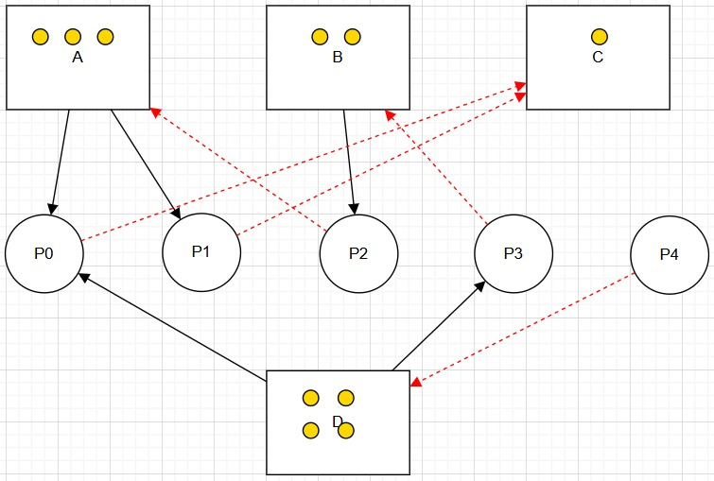

Solution:
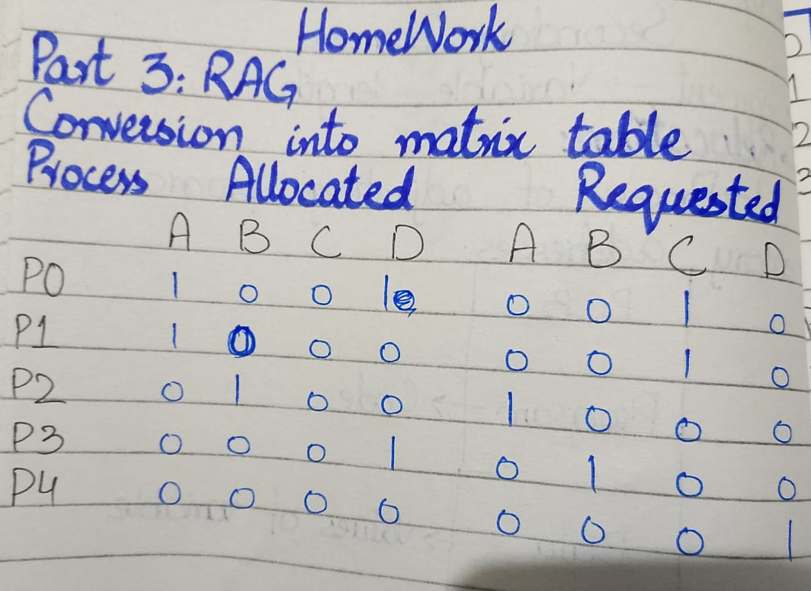
Part 4: Banker's Algorithm
System Description:
- The system comprises five processes (P0–P3) and four resources (A,B,C,D).
- Total Existing Resources:

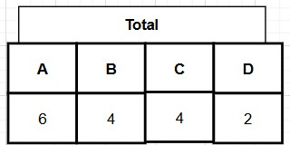

- Snapshot at the initial time stage:
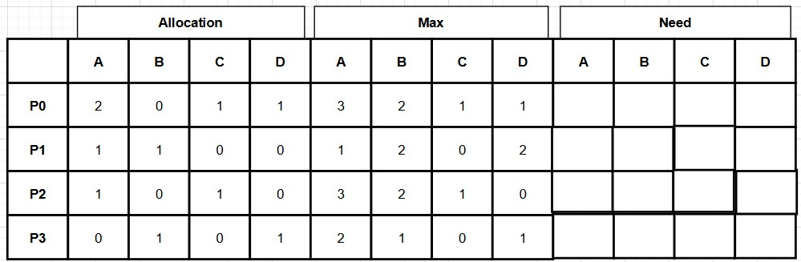
•
Questions:
- Compute the Available Vector:

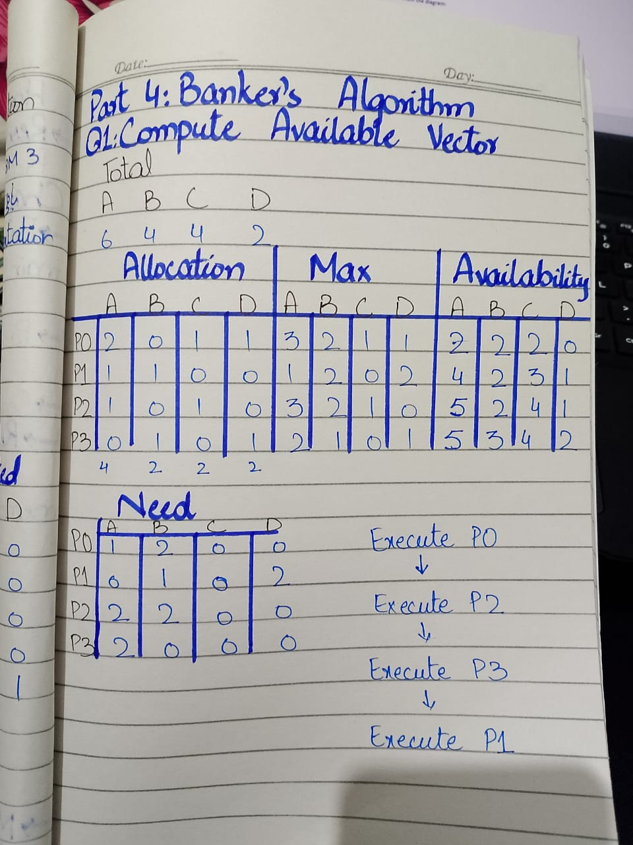
- Compute the Need Matrix:
• Determine the need matrix by subtracting the allocation matrix from the maximum matrix.
- Safety Check:
  - Determine if the current allocation state is safe. If so, provide a safe sequence of the processes.
  - Show how the Available (working array) changes as each process terminates.
Submission Guidelines:
  - Ensure all answers are well-explained and calculations are shown step-by-step.
  - Submit your assignment on MS Team and GitHub in a PDF format.
  - VIVA based Evaluation so Develop your own solution after getting help.

